# Smart Home based on ESP 32 (by Saif )

* It can control up to 3 AC devices & a AC Fan whose speed from 0-4.
* This project consists of temperature & humidity sensor for monitoring
* It can be controlled by ESP Rainmaker Mobile App & also Alexa & Google Assistent.
* Special feature of this project is that it remembers its devices state when main supply failure occurs, so that when power is back it automatically restore its devices state.
* For demo I used table Fan instead of AC fan
* Overall cost spend for this project was around 1600/-

# Components

|  |  |  |
| --- | --- | --- |
| NAME | Qnt | PRICE |
| ESP 32 Board | 1 | 500/- |
| 5v Relay | 6 | 25/- |
| DHT 11 **Temperature sensor** | 1 | 200/- |
| **1k ohm**  **resister** | 6 | 2/- |
| **Diodes**  **14007** | 6 | 3/- |
| **Transistors**  **BC547** | 6 | 10/- |
| Power supply5v | 1 | 300/- |
| AC Fanregulator | 1 | 70/- |
| Connectors **etc** | - | - |

# program the ESP32 using Arduino IDE.

**Update the Preferences –>** Additional boards Manager URLs: <https://raw.githubusercontent.com/espressif/arduino-esp32/gh-pages/package_esp32_index.json>

* Then install the **ESP32** board (Version: **2.0.3**) from the Board manager
* Download the required libraries

**SimpleTimer-master & DHT Library**

* After uploading the code to ESP32,
* Open the serial monitor, and select **Baud Rate: 115200.**
* hen **press and hold the BOOT button** of ESP32 for at least **4 seconds.**
* After releasing the BOOT button, a QR code will appear on the Serial Monitor.
* Now, **copy the URL**, just below the QR code, and **open the URL in a browser.**
* This QR code is unique, so you can print the QR code. Later on, if you want to change the WiFi details, you can use the same QR code.
* Scan QR code to Add Devices in RainMaker Dashboard
* Now open the ESP RainMaker App and**turn on Mobile Bluetooth and GPS (Location).**
* Tap on “**Add Device**“.
* **Scan the QR code** from the Browser and **Pair the Bluetooth**.
* **Enter the WiFi credentials** (WiFi Name & Password). Tap on “**Start**“.
* After the process is complete, tap on “**Done**“.
* Now, all the devices are added to the ESP RainMaker dashboard.
* Thus you can easily add devices to the ESP RainMaker app.
* Similarly, in ESP RainMaker App go to settings click on voice services

And we can easily add devices to **Alexa & Google Assistent**

# Circuit Diagram (it might vary according to the code)

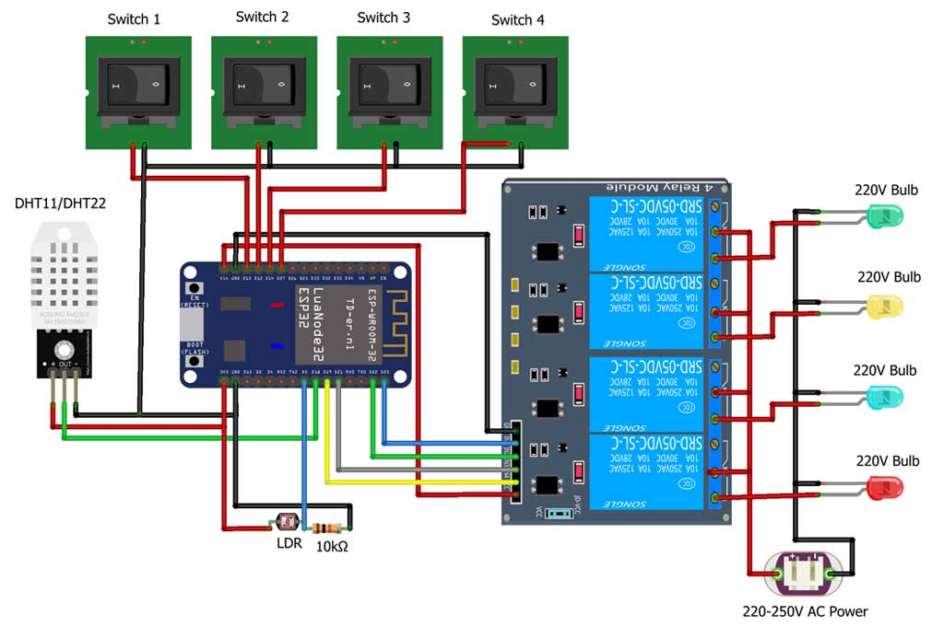

# PCB (selfmade):

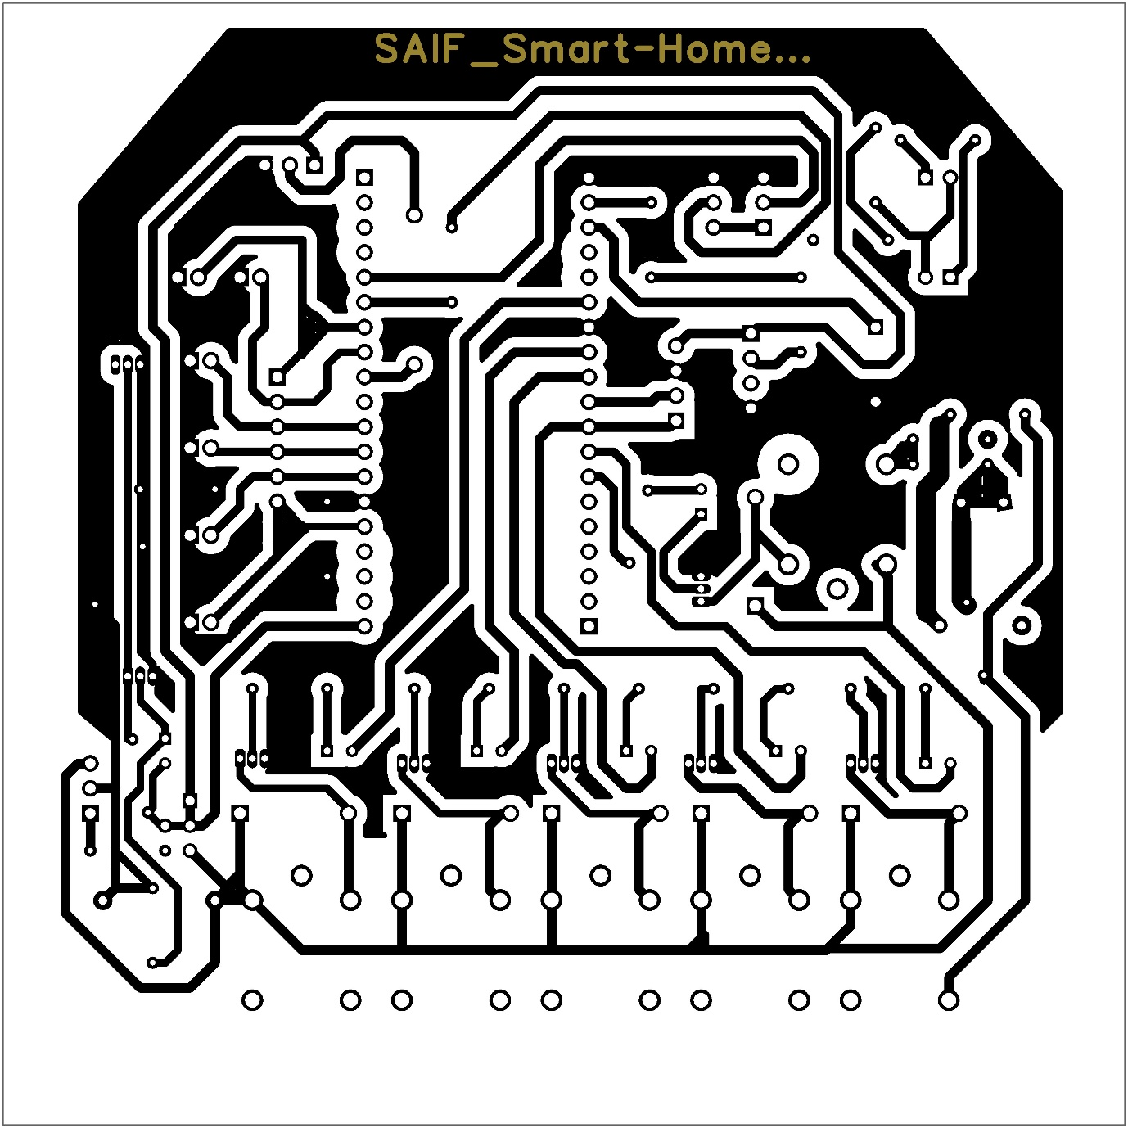

# Concept: